

**Information Processes & Technology**

Major Project Portfolio

Requirements and Design Report

Table of Contents

**Introduction** **3**

**Requirements Report** **4**

System Purpose 4

System Objectives / Requirements of System 4

**Design Report** **5**

Development Methodology 5

Project Deliverables 5

Features Deliverable 5

# **Introduction**

This report documents the requirements for producing a diverse multimedia product that will provide digital multimedia content for Staff and Students at St Pius X College for the purpose of supporting and encouraging teaching and learning, particularly in high order concepts and skills, on the subject of <Information Processes and Technology>.

Included in this document will be a Requirements Report including a clear statement of the system's purpose, a set of concrete objectives that will function co-operatively to achieve the system's purpose, and a timeline of tasks needed in each stage of this project to complete this task.

Following the Requirements Report will be a Design Report. This report includes details of each stage of the implementation and the expected deliverables from each stage.

# 

# **Requirements Report**

## System Purpose / Client Needs

The purpose of the system is to provide a diverse multimedia product that will all Teaching Staff to provide digital multimedia content for Students at St Pius X College (1) studying for the HSC for the purpose of supporting and encouraging teaching and learning, particularly in high order concepts and skills (2), on the subject of <Information Processes and Technology>.

In IPT, the main areas that will be covered in this product will be the Communications Systems (3), including Network Hardware, Network Topology, Message Generation and Transmission, Error Checking and Resolution ….

It is recognised that Students will have a variety of different learning styles and to engage and entertain, as well as enable learning, the system will need to provide content in variety of multimedia elements from text, to video/animation, and audio.

The system will need to be accessible from different locations on different devices and easily modified and deployed to Students

Note:

1. Clearly identify the Target Audience / Key Users of the System. They strongly influence the Purpose of system
2. Identify what SKILLS/KNOWLEDGE you are trying to support using your system.
   1. You can use dot points for this.
3. You can be specific about what features/sub topics in the Area that your product will cover.

### Social & Ethical Issues

The following are the Social & Ethical Issues that will be addressed in this Project

* Ergonomics
  + Usability
  + Accessibility
  + Consistency of Design
* Copyright
  + Content needs to be attributed
* Etc.

Note:choose from the following lists the most appropriate for your project

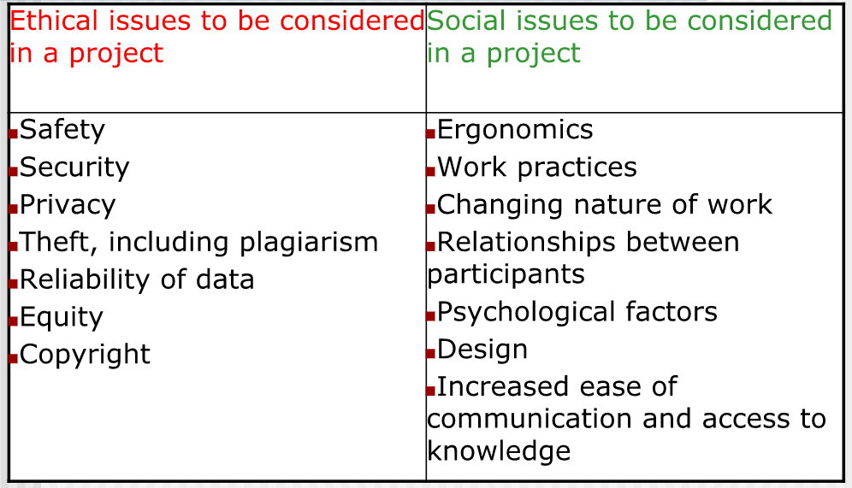

## System Objectives / Requirements of System

To address the needs of the key users, in this case the Students, the system will need to be <describe that type of system/tool will be built> (1) . It will be web-based to enable easy modification, management and deployment.

The multimedia content to be included in this product to support purpose (2) of the system include.

* Communication Systems Quiz - this will help a student to check their learning on a topic and enable them to identify areas of learning that need further study or investigation
* Youtube Video - that will clearly describe the differences between crc, checksum and parity checking.
* Network Hardware Gallery Page - documenting the different types of hardware devices in a network configuration
* Information Guides - particularly topics - including images/animation
* Podcast
* Presentation - describing….

Note:

1. an interactive multimedia online learning tool?
2. For each "Purpose", link what Functional Requirement will be used to fulfil that purpose.

### **Social & Ethical Issues Addressed:**

* How will the system address the above issues:
* Ergonomics of System
  + Consistent Design features
  + Appropriate Usability Features
    - Clear and consistent navigation
* Copyright
  + Credit for all sources of non-original content

# **Design Report**

## **Development Methodology**

We have considered different **Development Approaches** to this project, but in the end It was decided that the best approach for building and delivering the system would be in phases using **Agile Methodology** of development. This is due to the following reasons:

* <include all the reasons for choosing this method> (1)

We will review this development approach at the end of the project and comment on the suitability of this best approach.

The system will be delivered in two phases. Each Phase will take around 2-3 weeks - deliverable dates are given below

**Note:**

1. What reasons?: e.g.
   1. The modular nature of the system?
   2. Availability and close involvement of teachers and students in the development?

### **Project Deliverables**

1. This Requirement Report - DUE Term 2 Week 2 (dd/mm/yyyy)
2. Phase 1 - Interim Deliverable - DUE Term 2 Week 6 (dd/mm/yyyy)
3. Phase 2 - Final Deliverable - DUE Term 3 Week 1 (dd/mm/yyyy)

Note: a simple Gantt Chart may be included here, or in appendix, to support this list of Deliverables.

### **Features Deliverable**

The planning phase will include the following:-

* This Requirements Report documenting
  + Purpose
  + System Objectives/Requirements
  + List of Project Deliverables and timings.

The first phase will incorporate the following main objectives/features:

* Database Design to support the Quiz
* Website infrastructure setup
* The website will include:
  + Information Guides
  + Quiz
* Test Plan for testing the features
* Summary of Test of Results

The second phase will incorporate the following main objectives/features:

* Fixes/Enhancements raised from Testing in previous phase
* New Topics
* Additional content
  + Youtube Videos
  + Presentations
* Test Plan for testing the additional and new features and fixes